Chapter 8, Problem 21.

Calculate v(t) for t > 0 in the circuit of Fig. 8.75.

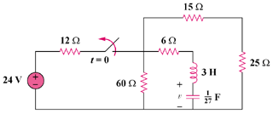

Figure 8.75
For Prob. 8.21.

